Thank you for choosing Happy Green Acres Campground
2 Green Acres Rd, Mallorytown, ON K0E 1R0 Province: Ontario
(343) 264-2468
CAMPGROUND RULES
Everyone must register at the office upon arrival. Check in at 1:00 PM and checkout is at 12:00 PM. An additional fee will be charged for early arrival or late departure.
An adult, at least age 21, must provide adequate supervision at ach site. Children under the age of 5 must be supervised at all times and are not allowed in any of the buildings alone. Anyone under the age of 18 must be on the site they are registered on by 10:00 PM. If not they must be accompanied by an adult from their site. One setup is allowed per site. Minor children may setup on the same site. 6 people per site maximum.
The campground speed limit is 10 KPH. Obey it at all times or you will be asked to leave the park.
Quiet hours are 11PM to 7AM and are strictly enforced. Power tools, saws, drills, etc. are prohibited, unless permitted by management.
Parking is allowed only on the site you have rented or in the designated visitor parking areas. Two vehicles permitted per site. Mini-bikes and motor-bikes are prohibited. Motorcycles may be used only as a form of transportation in and out of the park. Helmets must be worn at all times. Only licensed drivers are allowed to drive any vehicle. Children under the age of 15 must wear helmets while riding bikes.
Pets of registered campers are allowed provided they are leashed, cleaned up after, not aggressive, and their licensed pets cannot be left unattended. Visitors may not bring pets to the park. Campground staff has the right to prohibit any pets or breed at their discretion. First aid equipment is available at the pool as well as in the office. Do not remove safety equipment unless necessary in case of emergency. Golf carts to be approved by management for special needs only.
Your visitors must register at the office. A fee of $5.00 will be charged for each person between ages of 5 and 65. If visitors do not register upon arrival, the fee is $10.00 per person. Visitors must leave by 11:00 PM or be registered as overnight guests prior to 8:00PM. No new visitors may enter the park after 8:00PM.
Do not walk through the sites. Utilize the marked paths and roads.
Pool Rules: Pool is open from 10AM until dark. 2 persons 16 or older must be present for swimming to be permitted. Children under 16 must have a parent or guardian present in order to swim. Do not drink and swim. No glass bottles allowed on pool deck. Emergency phone is available in the office or dial 911. Diving is not permitted. No pets allowed on the pool deck or in water. Maximum 19 people at one time on pool deck or in pool. Any injuries or accidents must be reported to the office immediately. There is no life guard on duty, swim at your own risk. Only registered campers and registered guests are permitted to swim. . Due to Covid MAXIMUM 5 people allowed in pool area. Please book pool times through the office in advance.

Garbage: Dumpsters are provided for trash generated while camping here only. No appliances, rugs, cabinets, or furniture of any kind. Please leave the site in the same or better condition as when you arrived.
Do not cut any trees on the property. Fires are to only be built in the fire pit/ring provided. Do not move the fire pit/ring. Do not retire for the evening or leave your site until the fire is out. All fires are to be kept at a controllable level. Burning pallets, leaves, trash, scrap lumber, or furniture is prohibited.
Use of non OEM electric heaters, clothes washers, and clothes dryers is prohibited; you will be charged $250 and be asked to leave the park without a refund.

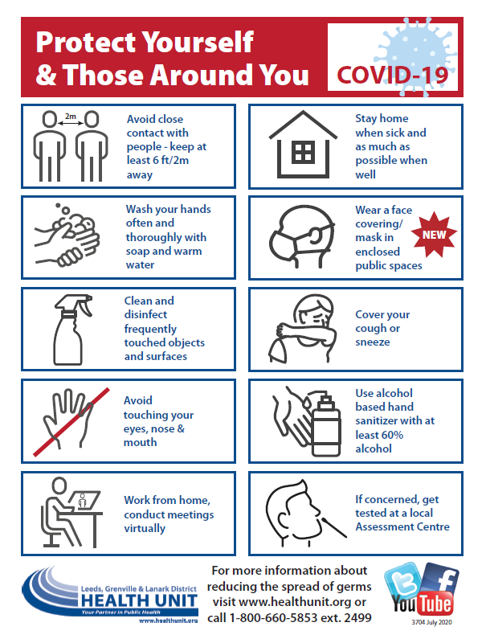
Happy Green Acres Code of Conduct 2021
This code is in effect from the June 1, 2021, to October 31, 2021

Campers,
Happy Green Acres Campground welcomes you!

Please read this Code of Conduct and review it with all family members. The rules in this Code must be followed to ensure we all stay safe and do not engage in activities that contravene any Provincial or Federal Government regulations and ensure we comply with all health regulations. Please remember to bring a mask and hand sanitizer/gloves for occasions you may need it.

This Code is over and above our normal campground rules, which still apply. Strict enforcement of all rules will be in place for all registered names on your occupancy agreement.

Any camper, regardless of age who breaches this Code will be asked to leave the campground immediately and your License of Occupation or booking will be cancelled immediately.

If you have a fever or flu-type symptoms, please stay home. If you have tested positive for COVID-19, are a presumptive case, or have been in contact with anyone who has tested positive or is a presumptive case, we request that you do not attempt to enter the campground. Please remain at your residence until you haven been cleared by your local health department and/or you have finished your self-isolation of 14 days.

At this time, we will be operating under the following rules. These rules may change as the Ontario or Federal Government
amends legislation.

Everyone must register at the office upon arrival.

Campers and Visitors

Campers and visitors allowed in the campground depend on the appropriate “Step” mandated by the Province of Ontario. The “Step” may be stopped by the emergency brake system. If you have questions, please consult the campground.

Sector | Before Step One | Step One | Step Two | Step Three
Gatherings | Outdoor gatherings of up to 5 people. | Outdoor gatherings up to 10 people | Outdoor gatherings up to 25 people | Outdoor gatherings with larger capacity limits
Short-term rentals (does not include hotels, motels, lodges, resorts, etc. but does apply to cabins and cottages) | Only for people in need of housing | Open | Open | Open
Ontario Parks and Campgrounds | Ontario Parks open for day use  Overnight only open for individuals in need of housing or with full seasonal contracts; only sites with electricity, water and sewage facilities may be provided for use  All recreational facilities in the campground and all other shared facilities in the campground, other than washrooms and showers, must be closed | Open | Open | Open
Marinas / Boating Clubs | Open with limited services including, repairs or servicing of boats, placing boats in water, and enabling individuals’ access to their residence or property  Recreational boating permitted but only members of a household can gather on a boat  Clubhouse, rec facilities closed; restaurants open for take-out only | Permitted with clubhouses, and other indoor amenities closed | Permitted with clubhouses, and other indoor amenities closed | Open with restrictions.

Common Areas:

Any common areas that are closed will have a posted sign. Please DO NOT enter these areas.

Facial coverings/masks MUST be worn inside enclosed public spaces/settings that are openly accessible to the public.
-Office/store
-Clubhouse (if open)
-Public bathrooms and laundry

“Face Covering/Mask” means: a cloth (non-medical) Mask, medical Mask, or other face coverings, (e.g., bandana, a scarf or cloth), for filtering respiratory droplets that securely covers the nose, mouth, and chin and is in contact with the surrounding face without gapping.

Walking around Campground: At all times campers must obey social distancing rules as mandated by the Province of Ontario. Currently, you must stay 2 meters or 6 feet away from other campers. You may use walking trails if social distancing rules are followed.

Limit of People on a Campsite: Until such time as the Government of Ontario amends the number of people allowed to gather, we are limiting the number of people allowed on a campsite to only the people listed and permitted on that site.

Children Under the age of 16: We expect that all parents will ensure their children will obey the rules 24/7. If your children cannot follow these rules, please do not bring them to the campground at this time.

Activities: Activities that can be undertaken obeying all social distancing and gathering restrictions will only be run.

Limit of campers in an area
Campers are expected to respect and obey all signage which restricts the number of people permitted in certain areas. Social distancing and gathering rules must be followed.

Office/Store
The office is open by appointment only. Please do not enter the office if you see another customer already inside.
Please line up outside of the office and obey all social distancing rules.
If you are with a family member, please ask them to remain outside unless it is required that they be present.

Please read all signs before swimming.
*Appointment Only*
Sunday – Thursday, 30-minute timeslots. (Maximum 1 hr. per day)
Friday and Saturday, 30-minute timeslots. (Maximum 30 minute per day)
Please TEXT 343-264-2468
-Date
-Time
-How many people
-Site number
Wait for the response “CONFIRMED” before entering the pool area.
-5 people maximum in pool or pool deck area at one time. Unless everyone in the pool is from the same family unit.
-You must obey social distancing rules as mandated by the Province of Ontario.

O. Reg. 265/21: Stay at Home Order Restrictions
If the province implements another emergency brake; seasonal campers who have a full season contract are permitted to enter the campground with the following restrictions:
• You must stay for more than 14 consecutive days before leaving the premises for non-essential reasons.
• If you need to leave the campground for any non-essential reason, you cannot return to the campground for 14 days.
• All physical distancing rules and gathering limits apply

Once the order is lifted, we will transition into the Roadmap to Reopen, while basing operations off the relevancy of Ontario Regulation 82/20.

Respect of others and staff
All Customers, guests and staff are responsible for respecting the dignity and rights of everyone at the campground. Every person has a right to expect their time at the campground will be without any type of discrimination or harassment. We will not tolerate, ignore, or condone discrimination or harassment and we are committed to promoting respectful conduct, tolerance and diversity at all times.

_____________________________
Camper Signature

_____________________________
Campground Signature

